ECE 2564

Project 3: Cookie Clicker

Fall 2025

How do I read this document?
Our goal has been to provide you with as much information and tools as possible to help you succeed with the project. Nevertheless, you might not need to read the entire document at first. We recommend that you take a quick look at it to know the main topics covered. Then, carefully read the Game Description and Code Quality sections, and begin your design. Once you have made some progress with your project, carefully study the Validation section. Whenever you have any questions, you should first try to find your answer in this document. The Design Strategy section contains tips and advice on completing certain parts of the project.

Fundamentals

!!! General Guidelines for any assignment
- Before you start working on your assignment:

  - Skim through the entire project description and carefully read the essential sections marked with exclamation marks (!!!).

  - Read the starter code carefully and in its entirety.

  - Run the provided F25_Proj3_golden.out on your board. This is an executable that we call the golden solution.

- Every time you sit down to work on your assignment:

  - Before you start coding, go to Piazza, and read the questions/notes related to the assignment you are working on, even if you took a two-hour break.

  - After you finish coding, push your changes to GitHub, even if you are going to take a two-hour break!

Starter Code
To get the starter code, follow the instructions for accepting assignments and importing projects from the CCS/GitHub Integration course website page. Please make sure to use GitHub Desktop or CLI. Instead of using the assignment link in the tutorial, you will need to use the below link:

https://classroom.github.com/a/ZZ6JIUfg

!!! Honor Code Policy
You are allowed to copy code from any previous program given to you as part of the course material (HW, class examples, course website, etc…) However, copying/inheriting code from outside/external resources constitutes plagiarism. If you have any questions whether your research or design falls under “fair use”, do not hesitate to contact the Professor, a GTA, or a ULA.

!!! Generative AI Policy
You are not allowed to use the code generated from Generative AI models such as ChatGPT, Gemini, Copilot… etc. However, you can use these tools to assist in debugging or enhancing the readability of your code.
Similarly, when writing your report, you may use Generative AI to improve and edit what you write, but you cannot use someone else’s writing as the input to the chatbot or ask the chatbot to write the report for you.
If you use Gen-AI either to polish your report or to polish your code, you need to download the entire conversation with Gen-AI as a pdf and attach it to your report as an appendix.

!!! Late Policy
Please refer to the syllabus for the late policy, which is very similar to the homework late policy in the past. The only small difference is that for projects, the report is due 24 hours after the code. Late penalties will be assessed based on the greater submission delay between the report and the code.

Golden Solution
We are providing a golden solution executable. The purpose of this file is for you to observe the behavior of the project in action. The executable is called F25_Proj2_golden.out and will be available in the Canvas file tab. Follow the instructions here to flash the microcontroller with the executable file. If there is any difference between the golden solution and the project description, please follow the project description. Please also bring that issue up on Piazza so that we are aware of it. (A “bonus” golden solution that contains some features that are considered a bonus may be provided for you. These bonus features are not required and are simply just examples. Please read this document carefully so you know what features are actually required.)

!!! Submission Process
The submission process has two steps:
- Submitting your code:
- Putting your code on the cloud:
You will have to submit your project to GitHub by the deadline. It is extremely important that you make sure that you have uploaded all your files, including custom images, if any, to GitHub.
For any reason, if you are unable to submit your work to GitHub, zip up your work, and fill out the Help Ticket form which has a place for you to upload it.
- Submitting a screenshot of your Github submission on Canvas.
2) Submitting your report, which is due 24 hours after the code deadline.
You will have to submit your report to Canvas as a pdf.

Button/LED Names
In this project, we will use the LEDs and buttons on both boards. We will use the same naming convention as our previous assignments as shown below. For the BoosterPack LEDs, we will refer to the collection of all three LEDs as BLED, which can be turned into a variety of colors.

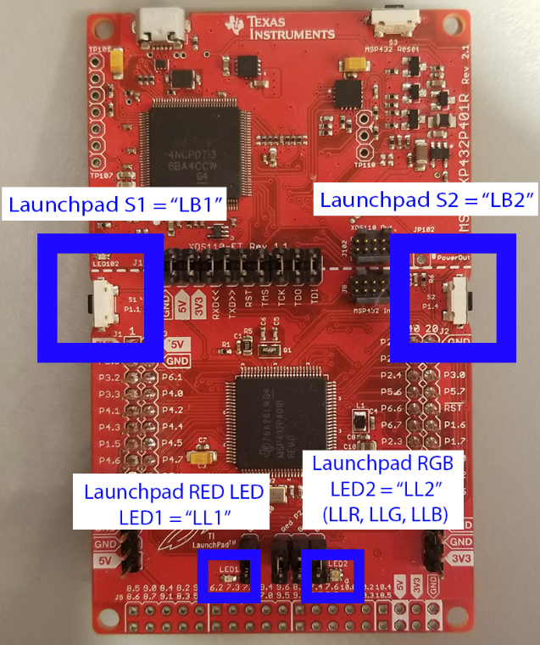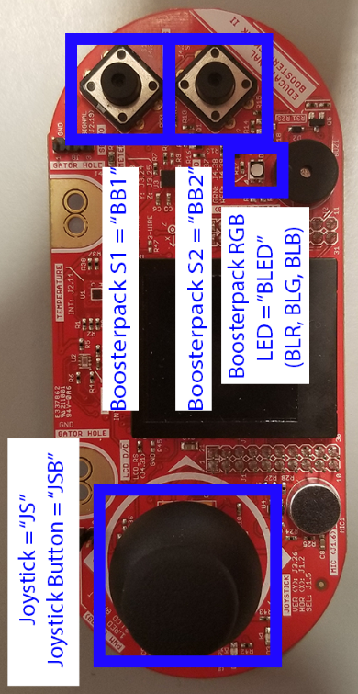

Game Description

Introduction
In this project, you will build a small version of the popular “Cookie Clicker” incremental game. Your job is to design a system where the player earns cookies by pressing buttons and strategically buys and sells upgrades and buildings to increase cookie production.

Splash Screen
When the player first boots the game, the player should be greeted with a title screen which should display the name of the game and the developer’s name (your name). After two seconds, this should switch to the main-menu screen. There should be no other input responses on this screen. The splash screen should have the name of the game and the developers name.
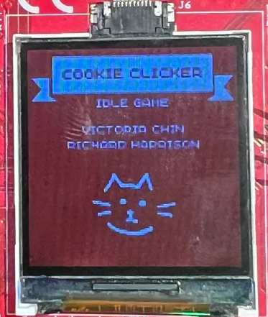

Main Menu Screen
This screen should provide two (2) options:
- Play the Game
- Go to the Instructions Screen
Players are given a cursor which they can move using the Joystick:
- Tapping (flicking) the joystick up moves the cursor up
- Tapping (flicking) the joystick down moves the cursor down
  - The cursor can circularly increment also.
Pressing JSB should go into the selected screen.

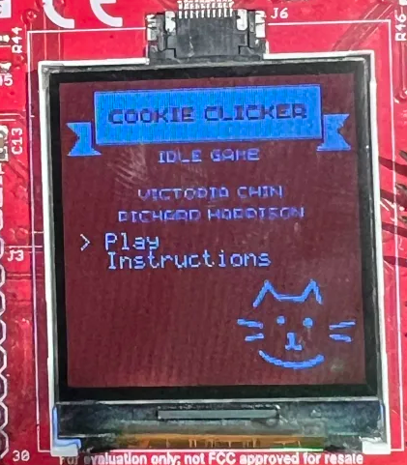

Instructions Screen
- This screen should transition from the Main Menu screen.
- It should contain an overall summary, in your own words.
- Pressing JSB should go back to the Main Menu screen.

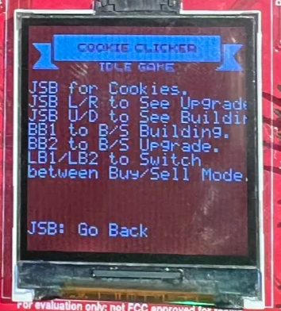

Game Screen

Start of Game
This screen should transition from the Main Menu screen.
When selected, the player is presented with the game environment:
- The interface displays a vertical list of Building Options, with the currently selected option highlighted by the cursor.
  - This may be circularly iterated (i.e., moving the cursor up from the very top option will automatically wrap around to the bottom, and vice versa).
- Upgrade Prices are displayed horizontally; directional arrows illuminate to indicate valid navigation paths (e.g., the right arrow lights up when the next upgrade is available, while the left remains dark if backward navigation is impossible).
  - This may be circularly iterated (i.e.,moving the cursor left from the very left option will automatically wrap around to the right, and vice versa)
- Additionally, the current transaction mode—indicating whether the player is in Buy or Sell mode—will be clearly highlighted
- Instantaneous Number of Cookies per Second should be printed as well (0 starting)
- Note: You do not need to emulate the golden solution’s UI, but you do need to follow the above described behavior.

- Starting Configuration Values:

 | Cursor | Grandma
Building Starting Price | 2 | 2
Building Price Multiplier | 2 | 5
Upgrade Starting Price | 1 | 2
Upgrade Starting Multiplier | 2 | 10
Upgrade Price Multiplier | 5 | 10
Upgrade Multiplier | 2 | 5

- Meanings:

- Building Starting Price
  - Definition: The initial cost (in Cookies) required to purchase the very first instance of this building type.
  - Usage: Sets the barrier to entry for the player to acquire the asset.
- Building Price Multiplier
  - Definition: The exponential scaling factor applied to the building's cost after each purchase.
  - Usage: Determines the "inflation" of the building cost. If the multiplier is 2, the price doubles for every new building bought Cost_{new} = Costcurrent × 2.
- Upgrade Starting Price
  - Definition: The initial cost (in Cookies) required to purchase the first tier of efficiency upgrade for the corresponding building type.
  - Usage: Sets the entry-level price for improving the building's performance.
- Upgrade Price Multiplier
  - Definition: The scaling factor applied to the cost of the upgrade tier.
  - Usage: Determines how rapidly the cost of upgrades increases.
- Upgrade Starting Multiplier
  - Definition: This is the amount of currency (Cookies) a single unit of this building generates per tick (or second) before any upgrades are applied.
- Upgrade Multiplier
  - Definition: This is the scale by which the Upgrade Starting Multiplier is increased by each time the upgrade is purchased.
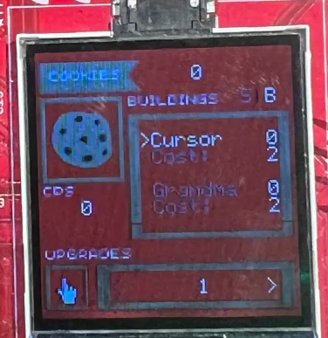
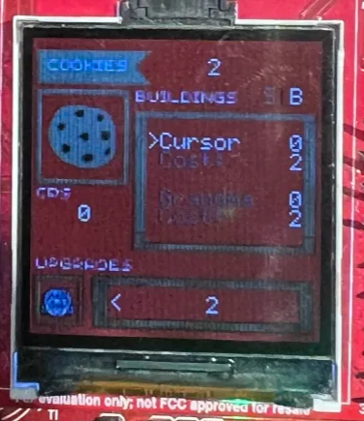

During the Game
- The LCD screen must provide real-time feedback to the player.
- The Total Cookie Count should update consistently as cookies are generated or spent.
- Furthermore, the Cookies Per Second (CPS) rate must immediately update whenever the player buys or sells buildings and upgrades, ensuring they always know their current passive generation rate.

Player Controls
- Tapping the Joystick Up or Down exclusively navigates the vertical list of buildings.
- Tapping the Joystick Left or Right exclusively navigates the horizontal list of upgrades.
- Tapping the Joystick increases the cookie count by 1.
- Tapping LB1 or LB2 toggles the game state between Buying and Selling modes.

Internal Mechanics
- If the player owns at least one Cursor, the game automatically adds x Cookies every 1 second.
- If the player owns at least one Grandma, the game automatically adds x Cookies every 5 seconds.
- Selling any building or upgrade refunds the full purchase price to the player.
- When an upgrade first becomes available, a specific buzzer sounds for 100ms to alert the player.
- While players are restricted from purchasing an upgrade unless they own at least one of the corresponding buildings, previously purchased upgrades are preserved even if all buildings are subsequently sold, allowing the player to sell those upgrades later if desired.
- Additionally, the numbers (i.e., prices, number of cookies, quantity) must be able to be represented using ‘k’, ‘M’, ‘B’, ‘T’, ‘Q’, ‘q’ respective to thousands, millions, billions, trillions, quadrillions, and quintillions once the number reaches these bounds like so.
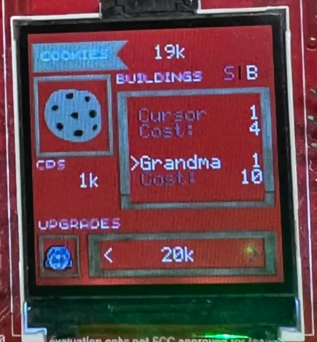

!!! Code Quality
Developing high-quality code is a very important skill for any programmer. A well-written program can be easily tested, updated, and shared with the rest of the team, whereas a low-quality program might “work” for a short period of time but will not be practical in the long run. In this course, you will strive to develop higher quality code to build your skills. We will focus on the below aspects for this purpose.

Comments
You should add enough comments to your code that makes it easy to read and understand. If you are not sure what level of documentation is enough, consult your instructor or your ULA/GTAs. You may also consult with TAs for suggestions on code-comments, but they are NOT the final arbiters of your grade.

No Global Variables
Your code should not use global variables. All interactions between functions should use parameter passing. The only exception may be a custom image (if you implement one) or the hardware timer rollovers.

No Numeric Values
Do not use any hard-coded numeric values inside your code (e.g. double circumference = 3.15 * 5) with the exception of 1 and 0. Instead of hardcoding values in your code, use macros to associate required values with symbolic labels (e.g. double circumference = PI * diameter). This rule does not apply to graphic functions, i.e. values used to change graphics colors or position display elements. However, it is strongly recommended to use macros whenever a value for a graphics setting is repeatedly used or if its purpose can be readily ascertained by providing a name (e.g. #define RED 0x00FF0000 is preferred to using 0x00FF0000 throughout your code).

No Long Functions
All functions, including the main function, should be less than 50 lines of code. This is to encourage you to build modular design with smaller functions that have simple and clear objectives. Comment lines, lines with only curly braces, and empty lines do not contribute to this 50-line count. Points will only be deducted for serious violations of this rule. If a function is very close to the requirement (52, 53 lines, etc.), that will be acceptable. If a function is above 60 lines of code (with the exception of provided libraries like grlib.h and ImageReformer files) you will receive a 0/30 for this score. If you find yourself with a function above 60 lines, extract clearly separable portions of code and encapsulate such code into new functions which you may then call in your original over-length function. CCS provides refactoring tools in the editor view which can assist with and automate this process.

Using HAL
You need to have a HAL for all your low-level hardware interactions, including buttons and LEDs. You may use your code from any previous homework or project to implement your HAL. Some code for HAL is given with the project.

Non-Blocking Code
Your entire application must be non-blocking. At any point during the operation of the game, pressing LB1 must turn on LL1. Releasing LB1 must turn off LL1. This operation is to make sure none of your code is blocking the processor from running in an infinite loop responding to user input, similar to a typical bare-metal embedded system.

Bonus Point Opportunities
Before you read about bonus opportunities, note that bonus features are supposed to build on top of a complete or near-complete project. Please do not use bonus points as a substitute for completing the core functionality of this project. You want to implement bonus features onto a game which you’ve gotten to mostly work, perhaps with a couple of bugs that you are still working on. However, if you’re unable to get the base functionality of the game working mostly reliably, please implement the rest of your project before asking about bonus features. ULAs and GTAs will not help you with implementing bonus features until you’ve already finished the core functionality of this project.

There are many opportunities to get extra points, the bonus points are capped at 150 bonus points, regardless of how many features you implement. Along with a standard golden solution, a “bonus” golden solution may be provided, which provides some working examples of the annotated features below. You are free to pick some features from the below list, or discuss new features with the instructor for additional bonus opportunities.

- [60-100] Extra buildings & corresponding upgrades with scrolling implementation (60 for first building, up to 3 buildings-upgrades)
  - Choose from the following list of buildings to implement:
    - Factory
    - Bakery
    - Cocoa Farm
    - Cafe
    - Bank
  - Make sure to push code before adding extra buildings!!!
- [15] Non building-corresponding upgrades (Up to 2 upgrades, max 30)
  - Increase the number of cookies the player gets when they tap JSB
- [30] Adding Events (Up to 2 events, max 60)
  - A golden cookie that gives you a lot of cookies randomly appears
- [5-25] Add a corresponding LED when a building is selected/highlighted on game screen
  - Must include table that shows which color corresponds to each building
- [10] Custom images (Up to 4 images will be counted, max 40)
- [60] Dark mode: For this bonus, you will have two color schemes for your screen: a light mode (default) and a dark mode (newly added). At the moment of entering the configuration screen, holding your finger over the light sensor (significantly reducing the amount of light received by the light sensor) flips the screen background and font color. So, if in your light mode, the background color is white and the foreground is black, in the dark mode, the background is black and the foreground is white.

!!!!!!!!!!!!!!!!!!!!!!!!!!!!!!!!!!!!!!!!!!!!!!!!!!!!!!!!!!!!!!!!!!!!!!!!!!!!!!!!!!!!!!!!!!!!!!!!!!!!!!!!!!!!!!!!!!!!!!!!!!!!!!!!!!!!!!!!!!!!!!!!!!!!
WE ARE NOT ACCEPTING ANY STUDENT PROPOSED BONUS POINTS FOR PROJECT 3
!!!!!!!!!!!!!!!!!!!!!!!!!!!!!!!!!!!!!!!!!!!!!!!!!!!!!!!!!!!!!!!!!!!!!!!!!!!!!!!!!!!!!!!!!!!!!!!!!!!!!!!!!!!!!!!!!!!!!!!!!!!!!!!!!!!!!!!!!!!!!!!!!!!!

!!! Bonus Points Grading
The amount of bonus points received is proportional to the amount of points received from the code-quality section (rounded down).

For example,
If you received 150/150 Bonus Points, but only 70/100 Code Quality Points, your resulting bonus points received will be:

0.70 (150) -> 105 Final Bonus Points

Design Strategy
This project will require more effort than previous assignments. It may take several dedicated days, if not the whole two weeks to complete, especially if you struggled in the previous homework assignments or struggle with programming in C in general. Based on our experience in the past, we highly recommend you start projects in this course as soon as possible. READ THE GAME SPECIFICATION IN ITS ENTIRETY AS SOON AS YOU CAN, so that you can start thinking about design issues you may encounter in your project sooner than later! Moreover, it is important you complete the milestone homework assignments in their entirety, even if the due dates for these assignments have passed, as they are foundational to this project.

In designing Project 3, we recommend the following strategy:
- Get your peripherals to work (I/O and hardware interfacing).
  - Turn on the green LED immediately before LPM function and off immediately after
  - Test interrupt-based button input and Timer32
  - Test interrupt-based buzzer and TimerA
- Design your application-level software abstractions on paper (e.g. FSM, pseudocode).
- Implement each feature delineated in your design outline, one at a time.
  - Utilize code from examples and previous projects when applicable
    - DO NOT USE POLLING-BASED IMPLEMENTATION
- Use the debugging techniques we learned in earlier assignments: breakpoints, viewing variables, using LEDs, …

As is always the case with any project involving code, always get your inputs and outputs working first before you work on the rest of the code. Import code from those previous examples, and ensure that your peripherals still behave as expected.

To test your peripherals, make simple helper functions which validate output as a function of input. The choice for how to do this is ultimately yours, but one simple example includes writing functions to toggle LaunchPad LEDs when you receive button presses.

Next, put away your code and get out a pen and some paper. The best software is designed with a pen and paper, not by hacking away with no stops until it barely works! Reread the project description and start jotting down some ideas for how you can implement parts of your project. Key components you may wish to consider in your design include the following:

- What kind of data do you need to represent your game? The application struct (and really ANYTHING besides the non-blocking check in the code we have provided) is completely yours to modify and extend. When you inevitably run into a problem where you require variables to maintain their values across many calls of your program, the Application struct is a good place to store some of those variables.

- If you find that the Application struct is getting too large, consider making other smaller structs to encapsulate variables, like the struct that exclusively holds variables you only need for the actual game.

- How will you draw each UI element onto your LCD? Draw a mock-up on your paper to get a good sense of what the final product should look like, and how each state variable in the game is represented on the LCD.

- When do you print an update to the screen? The LCD on your BoosterPack is slow. You cannot afford to clear and redraw everything on the LCD for every pass of your super-loop. You need to be more efficient than that. Try to keep your redraws to the screen to a minimum to reduce lag in your code.

- Think about places in your project where it would make sense to implement an FSM, one of the most powerful organizational tools you have at your disposal. Review the spec and make note of any transitions like button presses or specific inputs that cause a radical shift in the state of your program. Sketch an FSM diagram and make note of all the transitions. Determine which states your program might come back to and which ones will not be revealed.

- What are some ways in which you can incrementally develop your solution? Focus on small objectives, such as printing out the boxes in the right positions, accepting and interpreting the UART input characters and validating them, etc…

- In conjunction with the tip above, try to describe the general tasks that your code performs within specific states, under certain conditions, or on every loop. Breaking down the code into these general tasks can help you develop functions, which keeps your code modular and easy to understand. Give your functions descriptive names that clearly indicate what the functions do. Thinking about the mechanics of the program higher levels first will help you understand the general flow of your code before you start worrying about the low-level details.

- Don’t focus too much on making your project look perfect. Get your code working first, then focus on the aesthetics later. Just because your text is perfectly aligned doesn’t mean you can ignore the actual game mechanics behind it!

- It’s often a good idea to reset variables like arrays to some initial state when necessary. For example, if you only plan on updating part of an array, but the array contains old data that you don’t want, set everything in the array to some default state, then add in the new values. But if you plan on replacing the entire array all at once, there’s no sense in doing a reset if everything is going to be overwritten anyways. Whenever you write code, think about that code’s purpose and whether it is necessary to reset some variables.

As always, when implementing your code, practice an incremental approach. Implement each feature you have outlined on your paper one at a time, and immediately test the new feature you have just added so that you can detect possible bugs early!

Finally when using Git, use your commits wisely. We recommend committing your code after you successfully implement each new feature. This should seem obvious, but don’t commit broken code! If you know there is a bug somewhere, fix it before you commit. Each commit you make should be a checkpoint that you can roll your back to if you really must.

Project-Specific Strategies
- Be able to verbalize what you want your code to do before you write it. Follow the pattern of “do this thing when this other thing happens”.

Report
Write a short report with the following:

- Cover Page: This should include the title, date, institution (Virginia Tech), and course number. You must include your name, GitHub username, and a link to your repository on the cover page as well. You may choose the format, but the cover page needs to be in a professional form.

- Report Summary: In less than 50 words, summarize the purpose and content of your report.

- Project Description: A short section (a paragraph or two) describing what your application can accomplish. Ideally, this matches the Project Description. However, use your own words to describe it. State clearly which parts of the Project Specification are satisfied by your implementation. Take pictures of your game at various stages and include them in your report. If your application cannot perform all the tasks or performs some of them suboptimally, you need to mention them in this section.
Tip: Use the debugger to help you take screenshots!

- Microcontroller-Based Embedded System Architecture: To the best of your knowledge, draw a high-level architecture of the system you are using for your project. The drawing should be done on a computer using your program of choice such as Microsoft PowerPoint, Vision, Google Drawings, etc. Your figure should have at least two parts: board-level and chip-level view. In each level, only include the peripherals that are involved in this project. You do not need to draw two boards for the BoosterPack and the LaunchPad; a hypothetical unified board will suffice. We have not discussed this in class in detail, but the display is connected over SPI in the MSP432. Write a paragraph or two describing the architecture. Your description should explain what component on the board is connected to what peripheral on the MSP432, and how they communicate to the CPU (Hint: memory-mapped registers).

- Code Quality: Write one or more paragraphs about the various aspects of code quality you had to meet for this project. If your code does not meet the code quality requirements, describe the reason and your challenges. Create a table or a bulleted list with all the code quality headers in the project description with the number of points you expect to receive for that header. Add an extra row or bullet for the sum of points you expect to get for Code Quality.

- Bonus: Write one or more paragraphs explaining which bonus features your application achieves (if any), and how you implemented those. Create a table or bulleted list with the features you have implemented and the number of points you expect to get from those bonus features. Add an extra row or bullet for the sum of points you expect to get for Bonus Points.

Validation*
Feature | Point Values and Description
Low-power mode  [250] | Implement low-power mode (LPM) effectively to minimize power consumption during idle periods. The Green Launchpad LED LLG stays bright for the whole game utilizing the sleep() function for LPM and LED turning on/off. Turning LLG on outside the sleep function is a HONOR CODE VIOLATION. If the light turns dim for a portion of the game, 75 points will be deducted. If the light remains off for a portion of the game, 250 points will be deducted. (Small blinks < ¼ second are okay when drawing large graphics)
Title Screen [30] | [10] The title screen displays the project name and students name  [20] The title screen transitions to the menu screen after two seconds
Menu Screen  [50] | [40] Flicking the joystick up or down moves the cursor up or down  [10] Tapping JSB goes into selected screen
Instruction Screen  [20] | [10] A descriptive summary of the instructions of the game is present  [10] Tapping JSB returns to the main menu screen
Game Screen  [450] | [10] Formatting the numbers on the screen to display the appropriate prefix (i.e., ‘k’, ‘M’, ‘B’, ‘T’, ‘Q’, ‘q’)  [10] Displaying the instantaneous cookies per second based on the player’s purchased buildings and upgrades  [30] Updating the number of cookies the player has based accordingly to the timing of the upgrades  [50] Buzzer beeps when an upgrade is ready to buy, with a different note per upgrade  [200] 2 fully working buildings available in base game [100 per upgrade]  [60] 2 upgrades available in base game [30 per upgrade]  [20] Tapping JSB “clicks” a cookie, Tapping BB1 buys/sells buildings, tapping BB2 buys/sells upgrades, tapping LB1/LB2 changes the mode from buying to selling and vice versa [5 per button purpose, each action separated by a comma]  [40] Cookies paid and refunded accordingly to buy and sell buildings/upgrades [20 per buy/sell pair of buildings and upgrades]  [30] The cursor and words of only the item of interest and mode (buy/sell) being lit up [10 for the cursor on the buildings, 10 for the cursors for the upgrades, 10 for buy/sell]
Code Quality [100] | [10] Code is reasonably commented so that a TA can understand your code.  [20] #defines and constants are used instead of hard-coded numbers.  [30] No function exceeds 50 lines of code, within reason. Comment lines, lines with only a single curly brace, and empty lines do not contribute to this total. Points will only be deducted for egregious violations of this rule. If a function is very close to the requirement (52, 53 lines, etc) then that is also okay.  If a single function is above 60 lines of code (with the exception of provided libraries like grlib.h and ImageReformer) you will receive a 0/30 for this score.  [40] No global variables are used, with the exception of custom images using the Image Reformer and static interrupt variables.  [20] Your code is completely non-blocking. Pressing LB1 lights up Launchpad LL1 at any time.
Report  [100] | [10] No grammatical or spelling errors are present.  [10] Cover Page  [10] Report Summary  [30] Project Description  [30] Architecture  [10] Code Quality  [0] Bonus (only needed if you have completed any bonus features)
Bonus  [150] | Report any bonus features and record how many bonus points were earned, provide supporting information on how the bonus should be operated and whether or not it completes the required specifications.  If it does not, why justify your design decisions and how many points you deserve.  In your report, you are required to create a table or bulleted list with a row for each bonus feature, and an extra row dedicated to the sum of points you expect to get for each bonus feature.  Points received from bonuses use the following formula:  Final Bonus = [Code Quality %] * [Raw Bonus]
Total (without Bonus)  [1000] | [1000] Standard Implementation  [150] Possible Bonus points

